CommuteCO₂
Unit Code: IT5002
Authors:
Zaynab Salman, Ayden Smith, Gula Tang

Introduction 3
Background & Goal 3
Problem Statement 3
Proposed Solution 4
Features 4
Value 4
Key Stakeholders 5
User Journey 6
Wireframes 8
System Architecture & Data 10
Data Sources 10
Success Criteria 10
Sponsors 11
Conclusion 12
References 13
Appendix A - Ethics Canvas 14
Appendix B - Lotus Blossoms 15

Introduction
Transport is one of the largest sources of greenhouse gas emissions both in Australia and around the world, with road vehicles accounting for a substantial share. For many people the daily commute is the most emissions-intensive part of their day, yet the climate impact of that journey is largely invisible: a commuter who drives to work each morning has no easy way to see how much CO₂ that trip produces, or how much they could avoid by taking the train, cycling or walking instead.
Awareness of climate change is at an all-time high, with action against climate change at the forefront of many governmental policies and personal beliefs. The barrier is not willingness but information, when emissions data is published, it is published as audit reports with a focus on measuring per-industry rather than how people can understand their personal contributions to emissions.
This project aims to respond to that gap by proposing CommuteCO₂, a carbon footprint comparison platform for everyday travel.
The report covers the problem and the research behind it, the proposed solution and what it will do, the commuters it's built for, how the build is scoped and architected, the data behind it, and who might sponsor it.

Background & Goal
As outlined in the UN’s Sustainable Development Goal13: Climate Action, every person in every continent is affected by climate change. According to research (Chen & Liao, 2025) globally 86% of the population is concerned with climate change. Whilst the primary responsibility lies with businesses and governments, there are many things that individuals can do to help fight greenhouse emissions, according to Fitzpatrick et al. (2015) it is difficult for individuals to reduce their carbon footprint with a need for societal change and personal education to achieve footprint reductions. To reduce this footprint we need to educate society on how their choices can impact the environment around them.

Problem Statement
A commuter feels worried about their daily travel’s impact on the planet needs to understand the emissions of their travel options and the potential savings of choosing a lower-carbon option, but existing emissions data is built for industry reporting and audits, not individual journeys, leaving them without accessible, simple, personalised information to make better choices.

Proposed Solution
CommuteCO₂ is a web-based carbon footprint comparison platform for everyday journeys. A user enters a start and end point, and the platform returns a comparison of estimated CO₂ for the various methods of transport for that route, with the saving against driving shown for each alternative. The user then records the mode they travelled by, and that saving is added to regional and global totals, so an individual choice contributes to a visible collective result. A separate dashboard lets users select a country and see its total transport emissions and their share of national emissions, giving context to the comparison.
The calculations are planned to be kept simple, the backend resolves the route to a distance and multiplies that distance by a published emissions factor for each mode that are stored in the database rather than hardcoded, allowing for easy migrations for new published data.

Features

Feature | Priority
Route input (start and end point) | Must
Distance calculation between the two points | Must
Comparison of emissions via method of travel (driving, train, bus, cycling and walking) | Must
Comparison showing kg/CO₂ per method | Must
Store “Emissions Saved”, (Not storing PII or location data) | Must
Transport emissions dashboard (Global or regional) | Must
Regional and global totals of emissions saved | Must
Emission Savings Breakdown | Should
Route display | Could Have
Customised Emissions for User’s vehicle | Could have

Value
This platform does not aim to be a navigational tool, but rather aiming to answer simple questions for climate conscious users, how much does this trip produce and what difference would it make to users if they change it.

Key Stakeholders
CommuteCO₂’s primary stakeholders are environmentally conscious commuters in Australian cities who want to reduce the carbon footprint of their daily journeys. They need clear comparisons of their transport choices to understand the potential emission savings and how their efforts contribute. For this, a streamlined interface with understandable figures is critical to meeting their needs.
Several secondary stakeholders can contribute to the platform’s success.
Stakeholder | Interest in the project | Influence | Requirements & Needs
Local councils | Supporting community awareness of transport emissions and local climate action. | Medium:Provides local context and spreads awareness. | Clear regional summaries and explanations of how recorded savings are calculated.
Transport agencies | Helping commuters understand public transport as a lower-carbon travel option. | Medium: Contributes transport expertise and feedback on comparisons. | Appropriate transport categories, documented emissions factors and consistent comparison methods.
Employers and universities | Encouraging sustainable commuting among staff and students. | Medium: Can reach potential users and support testing through existing networks. | An accessible tool that makes regular journeys easy to compare and potential savings easy to understand.
Environmental organisations | Turning climate information into practical everyday choices. | Medium: Can contribute communication expertise and encourage participation. | Clear comparisons and a meaningful connection between individual travel choices and community impact.
Data providers | Accurate interpretation and attribution of their information. | High: Data quality and availability underpin the calculations and dashboard. | Visible sources, dates, units and explanations of how their data is used.

User Journey
The following breaks down how the user's journey through the application will work, separating the journeys by function.

Legend: Red: Trip Selection, Blue: Community Impact
ID | Epic | Purpose
E1 | Route input | Lets users define a trip and get its distance.
E2 | Emissions comparison | Shows CO2 per mode for that trip.
E3 | Savings tracking | Records the mode the user chose and the saving.
E4 | Community impact | Shows total CO2 saved by region and globally.
E5 | Emissions dashboard | Shows transport emissions by country.
E6 | Data, privacy and platform | Stores fctors, imports adatasets and protects users.
User Stories
Each epic is broken down into user stories that describe what someone needs from the platform. They’re written from the point of view of a commuter, a general user or a developer.
E1 Route input:
- 1.1 : As a commuter, I want to enter a start and end point so that I can see how far my trip is.
1.2 : As a commuter, I want to use my current location so that I don’t have to type it in.
E2 Emissions comparison:
- 2.1 : As a commuter, I want to see the CO2 for driving, bus, train, cycling and walking side by side so that I can see which is lowest.
- 2.2 : As a commuter, I want to see how much I’d save compared with driving so that I know if switching is worth it.
- 2.3 : As a driver, I want to choose my vehicle type so that the driving figure matches my car.
- 2.4 : As a user, I want to see where the numbers come from so that I can trust them.
E3 Savings tracking:
- 3.1: As a commuter, I want to pick the way I travelled so that my CO2 saving is recorded.
E4 Community impact:
- 4.1 : As a user, I want to see the total CO2 saved in my region and globally so that I can see the bigger picture.
- 4.2 : As a user, I want to see savings broken down by transport mode so that I can see which choices help most.
- 5.1: As a user, I want to pick a country and see its transport emissions so that I understand the scale of the problem..
- 5.2 : As a user, I want to see how those emissions have changed over time so that I can see the trend.
E6 Data, privacy and platform:
- 6.1 : As a developer, I want the emission factors and datasets stored in the database so that the calculations are consistent.
- 6.2 : As a user, I want my start and end addresses not to be saved so that my privacy is protected.
- 6.3 : As a mobile user, I want the site to work on my phone so that I can use it on the go.

Wireframes
The following wireframes show the main screens that users will interact with. These screens have been designed to be simple and informative rather than visually overwhelming.
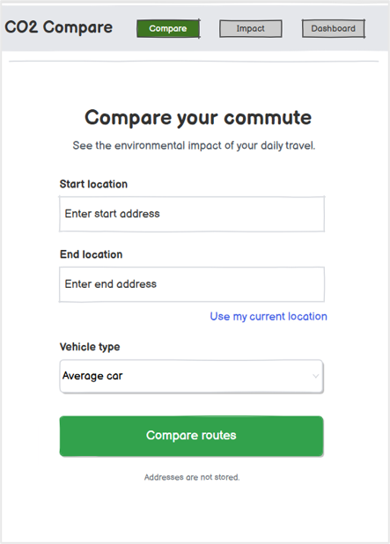

Screen 1: Route input
This is where a commuter starts. They type in a start and end address, or use their current location, and can pick their vehicle type so the driving figure fits their car. There’s a short note underneath saying addresses aren’t stored, so people know their locations stay private.

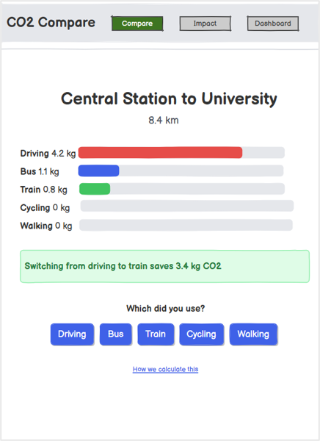
Screen 2: Comparison results
After comparing, the user sees the trip distance and a bar for each way of travelling, so the difference in CO2 is clear at a glance. A highlighted box tells them how much they’d save by switching from driving, and they can tap the option they used so their saving is recorded. There’s also a link explaining where the numbers come from.

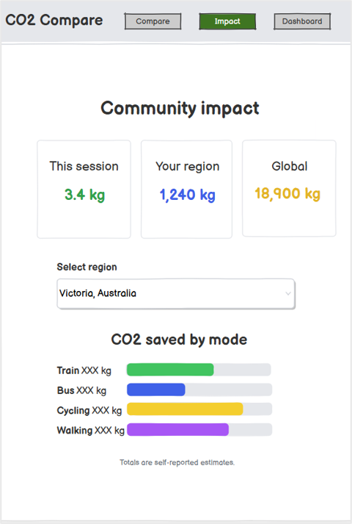

Screen 3: Community impact
This screen shows how much CO2 has been saved by the user in this session, in their region, and across the world. The user can change the region, and a chart breaks the savings down by transport mode. A small note makes it clear the totals are self-reported estimates.

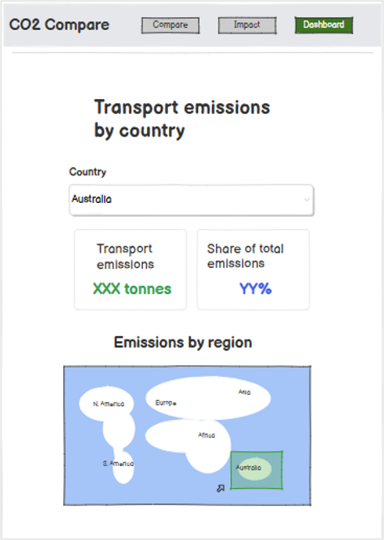
Screen 4: Emissions dashboard
The dashboard lets people pick a country and see its total transport emissions and how much of its overall emissions that makes up. It’s there to show the scale of the problem and explain why changing how we travel matters.

System Architecture & Data

Architecture | Choice | Notes
Front-end | Vue.js SPA | SPA, responsive
Database: | Supabase (Postgres) | Read-only emission factors, no PII stored.
Route/  Distance Service | OpenRouteService | API used to gather route/distance data.

Data Sources
The following outlines what data is used and how they contribute.
Source | Name | What it provides
Kaggle | Vehicle CO₂ emissions | Per Vehicle CO₂ emissions
Climate Council | Transport Emissions: Driving Down Car Pollution in Cities (FactSheet) | Average factors for public transport (Rail, bus, car) by gCO₂/km
GIZ | Country-Level Yearly GHG Emissions + Transport Sector (1970-2024) | National Transport Emissions Shares by year
Our World In Data | CO2 and Greenhouse Gas Emissions dataset | Provides statistical data related to climate change:  CO2 emissions (annual, per capita, cumulative and consumption-based), and other greenhouse gases.

Success Criteria
CommuteCO₂ will be evaluated against the following proposed acceptance targets for the completed prototype.
Criterion | Target
Comparison accuracy | All 10 reference trips match manual emissions and savings calculations within ~0.01 kg CO₂.
Dashboard accuracy | Five country/year cases match GIZ transport totals and national shares at the displayed precision; 10 test trip records produce correct regional and global savings totals, counted once each.
Response time | At least 9 of 10 comparisons display results within five seconds of submitting valid locations.
Ease of use | At least four of five target commuters independently compare a journey and record their chosen mode within two minutes.
Climate understanding | At least four of five participants identify a lower-emission option and explain the estimated saving against driving.
Data transparency | At least two selected data sources are used, with source, year, units and calculation boundaries shown; emissions factors are read from the database.
Journey privacy | All 10 test records store only mode, distance, estimated saving, region and date.
During development, a teammate will manually recalculate the reference trips, compare country figures with GIZ source rows, and use 10 known journey records to check totals and stored fields. Database queries and a source-label review will check data transparency. On the deployed build, the team will time 10 comparisons on the same device and network. Before final handover, five target commuters will complete an observed comparison-and-record task and explain their results; task times, completion and answers will be recorded. Failed checks will be repeated after fixes.
Source notes will identify the selected Kaggle vehicle data as illustrative, the Climate Council factors as dated 2017, and GIZ national totals as historical CO₂e. Trip savings are self-reported CO₂ estimates; walking/cycling zeroes cover direct travel emissions.

Sponsors
Potential sponsors include Monash University, City of Melbourne, Bicycle Network and the Climate Council. Each connects to CommuteCO₂’s focus on sustainable commuting or climate awareness.
Monash University encourages active travel, public transport and lower-emission commuting through its Net Zero transport work (Monash University, n.d.). CommuteCO₂ could support campus travel awareness and offer a practical student sustainability project. We would seek a small staff/student pilot, help recruiting testers and sustainability advice.
City of Melbourne prioritises walking, cycling and public transport in its Transport Strategy 2030 (City of Melbourne, 2019). The platform could make these choices easier to understand through trip comparisons. We would seek feedback on local relevance and promotion through community channels.
Bicycle Network encourages everyday cycling to work through Ride2Work (Bicycle Network, n.d.). Showing estimated savings against driving could complement its commuter outreach. We would seek cyclist feedback, introductions to workplace participants and promotion around commuting activities.
The Climate Council provides accessible climate information and advocates evidence-based solutions (Climate Council, n.d.). CommuteCO₂ could extend its transport education through journey comparisons. We would seek feedback on explanations and appropriate use of its published transport material.
Recommended shortlist: We would approach Monash University first for a focused campus pilot, City of Melbourne second for local relevance and community reach, and Bicycle Network third for its workplace cycling network. This shortlist balances pilot feasibility, alignment with urban commuting and access to feedback. The Climate Council remains an advisory candidate.

Conclusion
A product for those who are seeking to make a change and see actionable results.
Useable by anybody who wishes to make a change see how their actions influence the cause to fight climate change .

References
Chen, J., & Liao, H. (2025). Global public perceptions of climate change risks and their determinants. Climate Policy, 1–16. https://doi.org/10.1080/14693062.2025.2562025
Bicycle Network. (n.d.). Ride2Work. https://bicyclenetwork.com.au/rides-and-events/ride2work/
City of Melbourne. (2019). Transport strategy 2030. https://mvga-prod-files.s3.ap-southeast-4.amazonaws.com/public/2024-05/transport-strategy-2030-city-of-melbourne.pdf
Climate Council. (n.d.). About Climate Council. https://www.climatecouncil.org.au/about/
Climate Council. (2017). Transport emissions: Driving down car pollution in cities. https://www.climatecouncil.org.au/wp-content/uploads/2017/09/FactSheet-Transport.pdf
Fitzpatrick, J. J., McCarthy, S., & Byrne, E. P. (2015). Sustainability insights and reflections from a personal carbon footprint study: The need for quantitative and qualitative change. Sustainable Production and Consumption, 1, 34–46. https://doi.org/10.1016/j.spc.2015.05.004
GIZ. (2026). Country-level yearly GHG emissions transport sector (1970–2024) [Data set]. https://portal.transport-data.org/@giz/country-level-yearly-ghg-emissions-transport-sector-1970-2024
Monash University. (n.d.). Net zero emissions. https://www.monash.edu/campus-sustainability/sustainability-strategy/net-zero
Şahan, B. (n.d.). Vehicle CO2 emissions dataset [Data set]. Kaggle. https://www.kaggle.com/datasets/brsahan/vehicle-co2-emissions-dataset
Ritchie, H., Rosado, P., & Roser, M. (2023). CO₂ and greenhouse gas emissions. Our World in Data. https://ourworldindata.org/co2-and-greenhouse-gas-emissions

Appendix A - Ethics Canvas
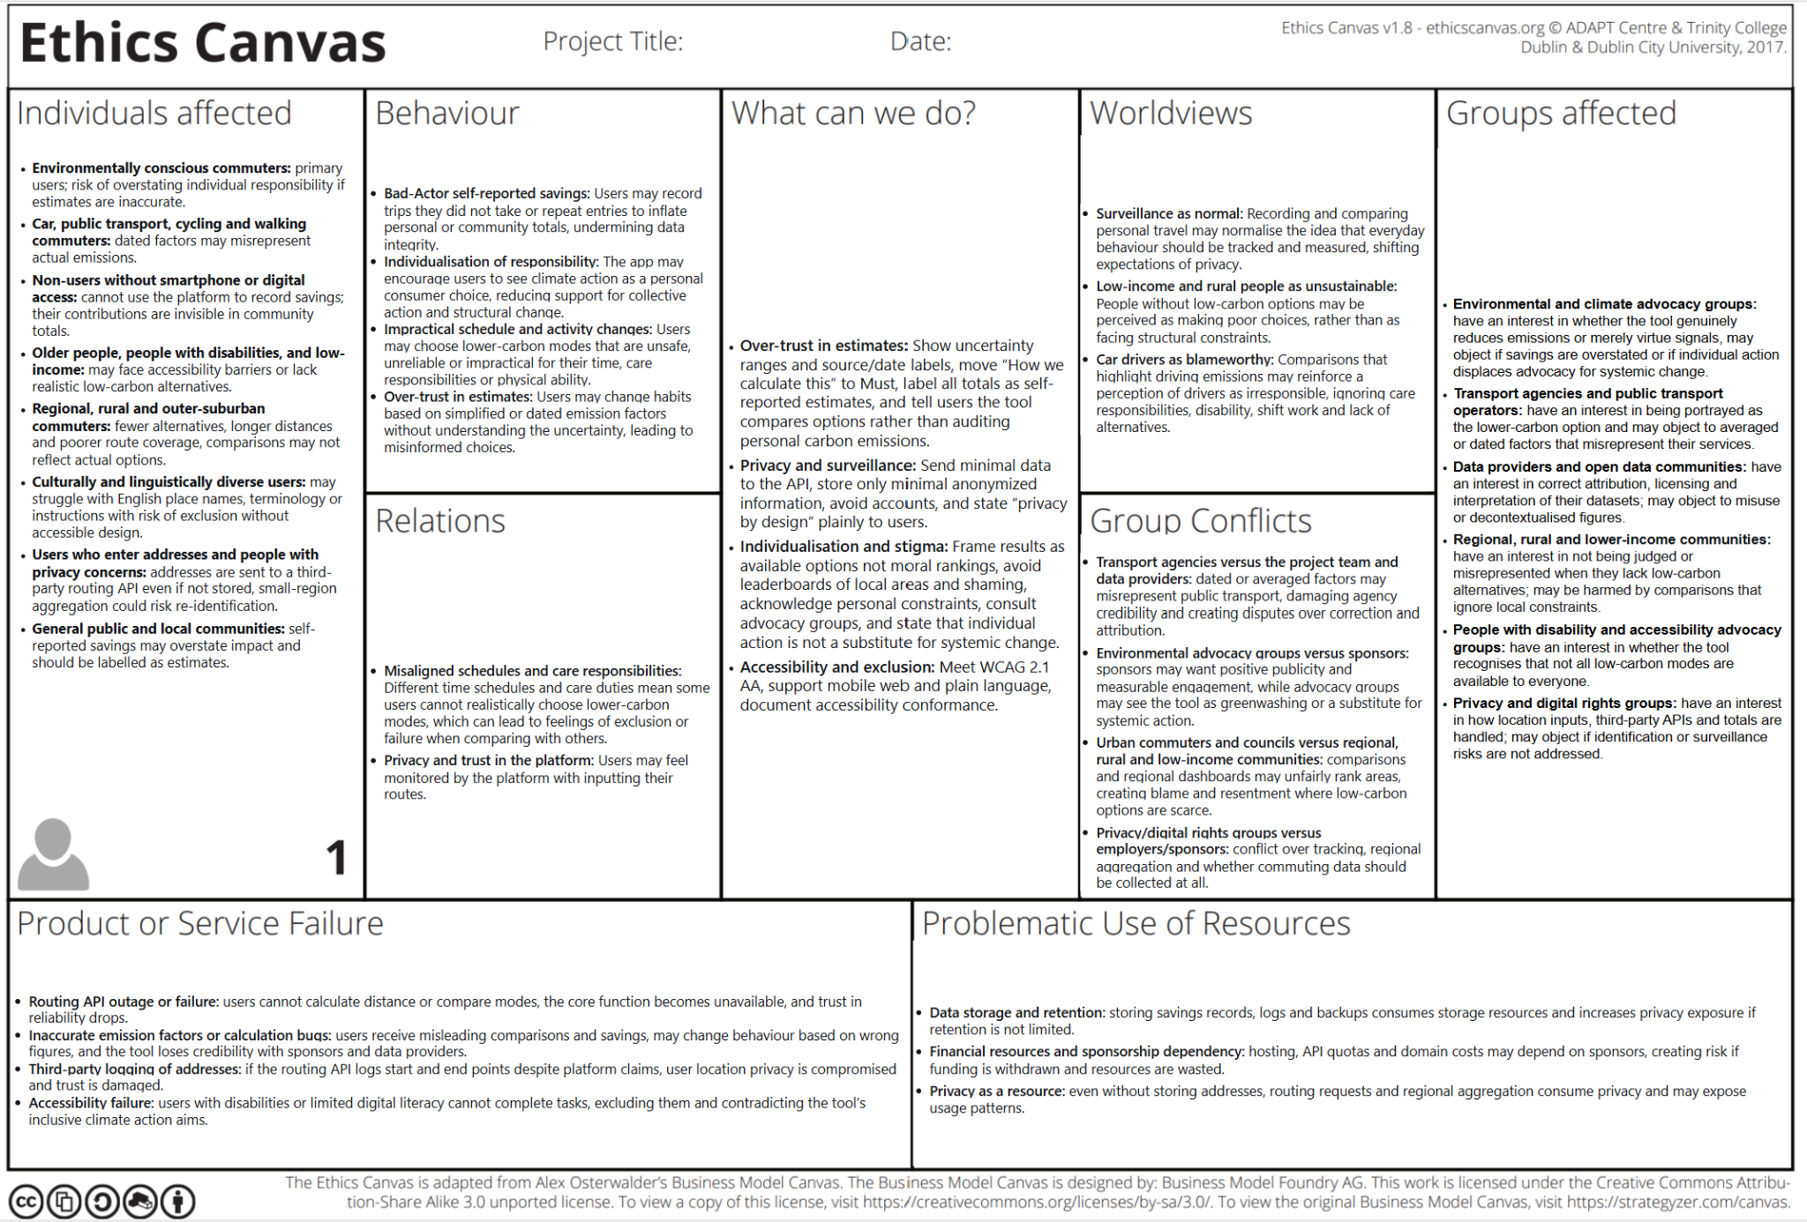

Appendix B - Lotus Blossoms

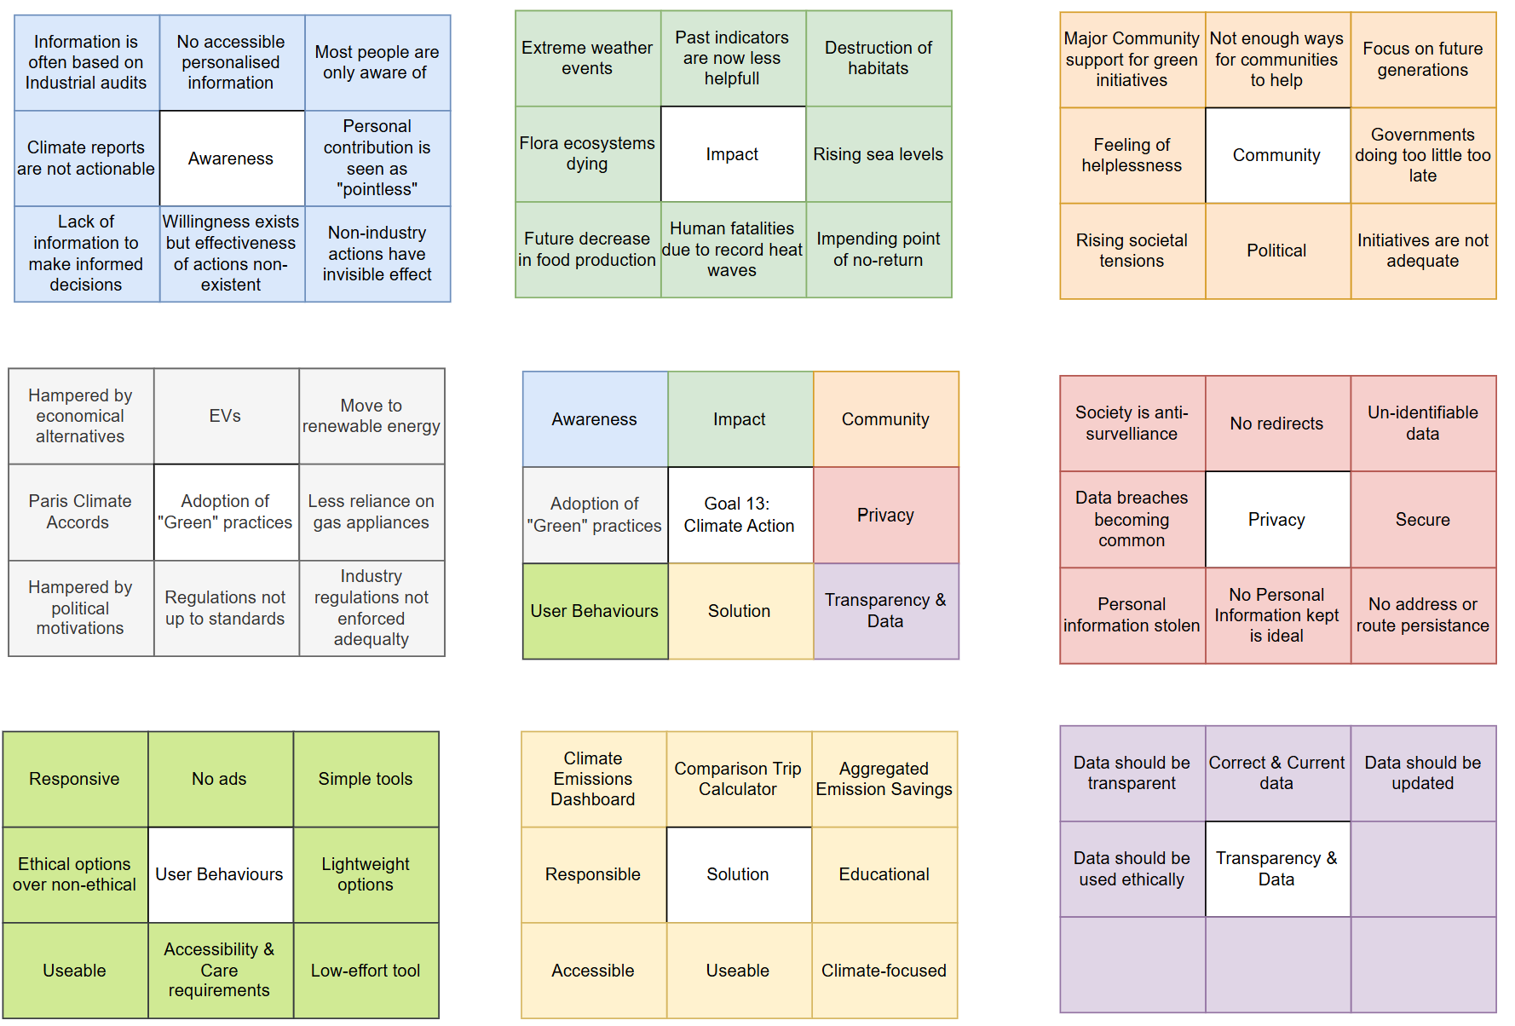
Appendix D – Entity Relation Diagram


